**Name: VISHNU SADASIVAN**

**Roll No:52**

**Batch:MCA**

**Date:**

**NETWORKING & SYSTEM ADMINISTRATION LAB**

**Experiment No.: 1**

**Aim:**

Install the latest version of Ubuntu on an Oracle VM VirtualBox.

**Procedure:**

Step 1: Installation of virtual box.

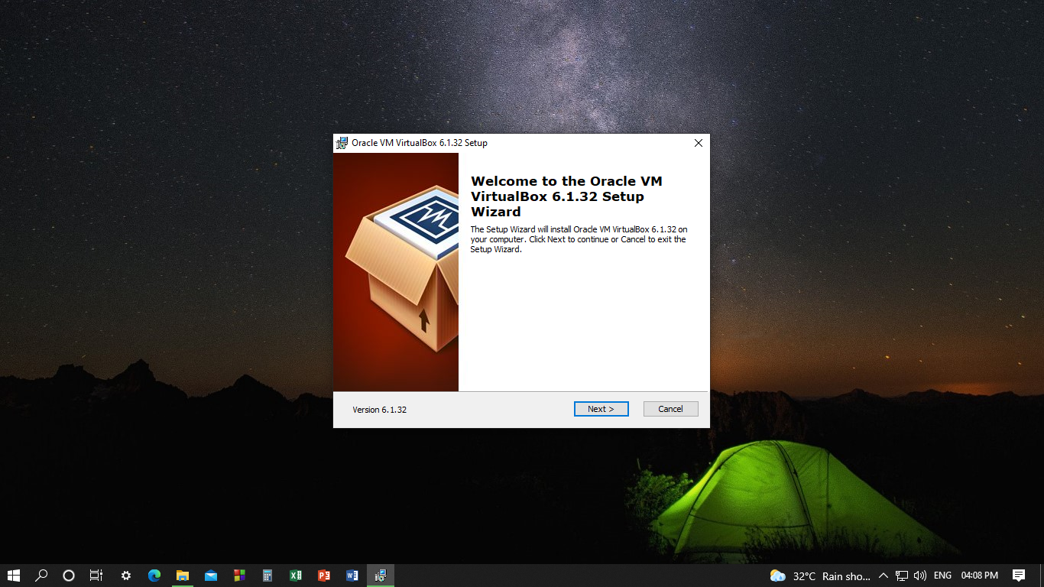

Step 2:Change current destination folder.

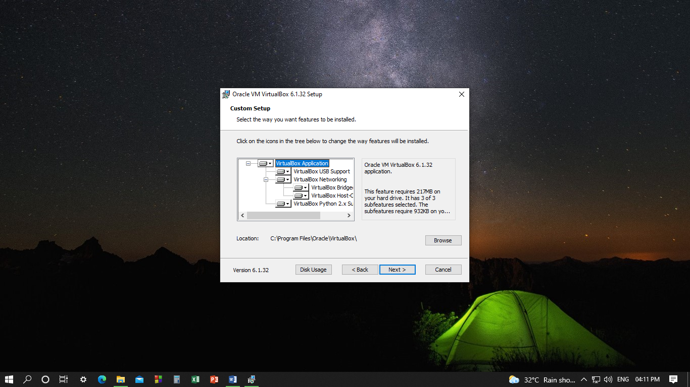

Step 3: Select a way to install your features .

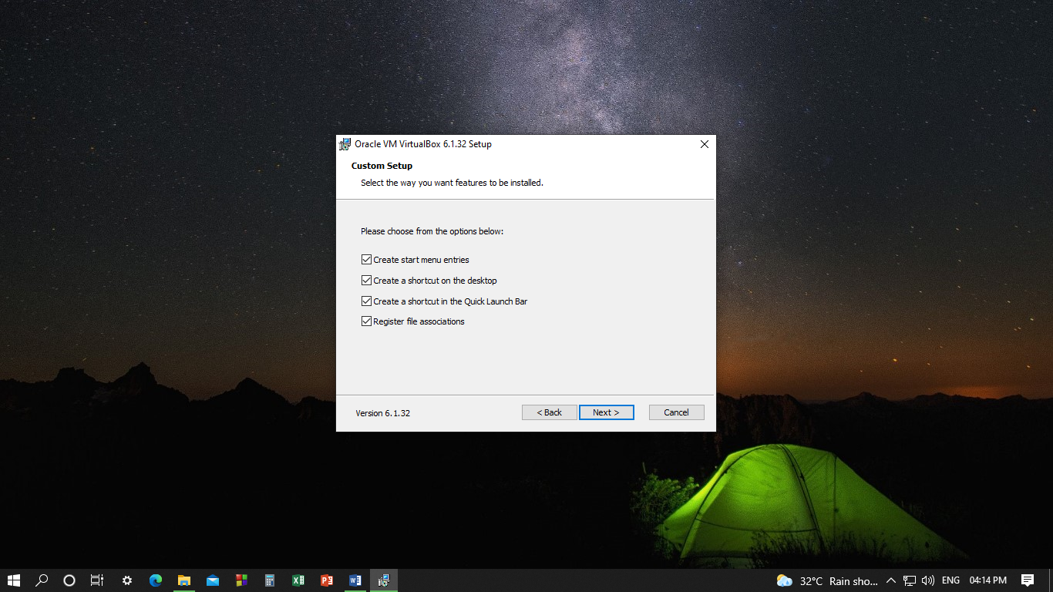

Step 4: Installation procedures.

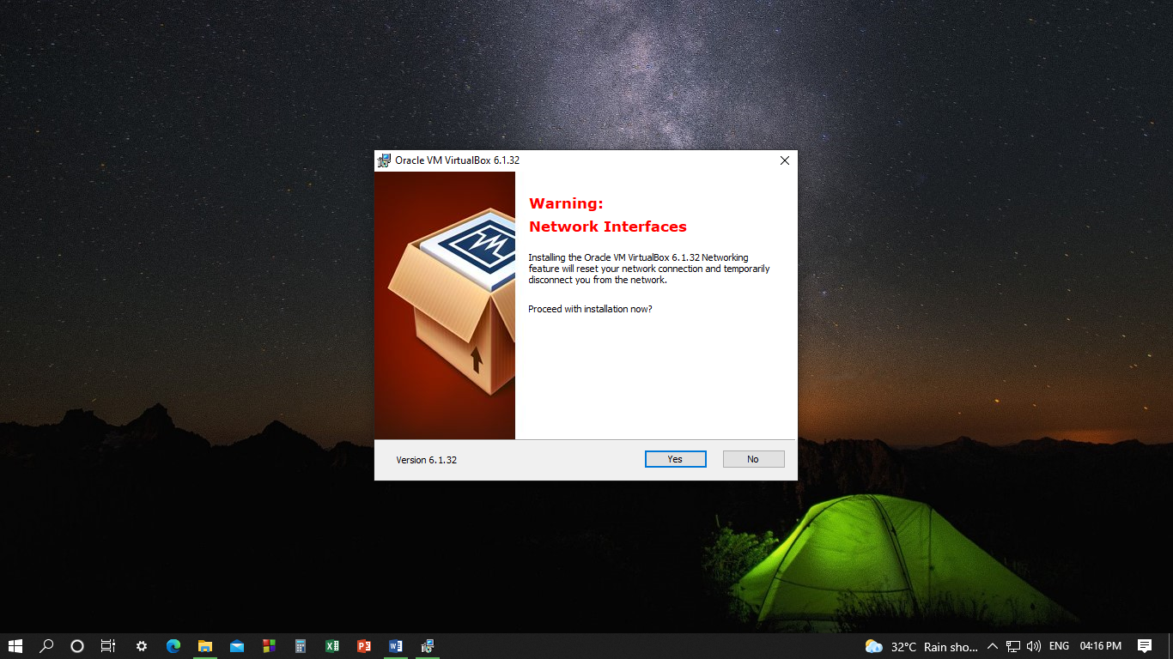

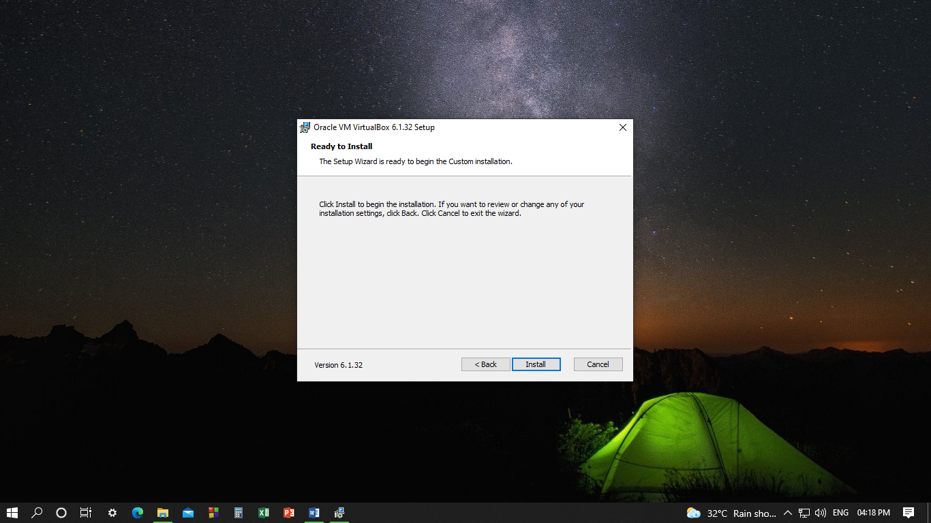

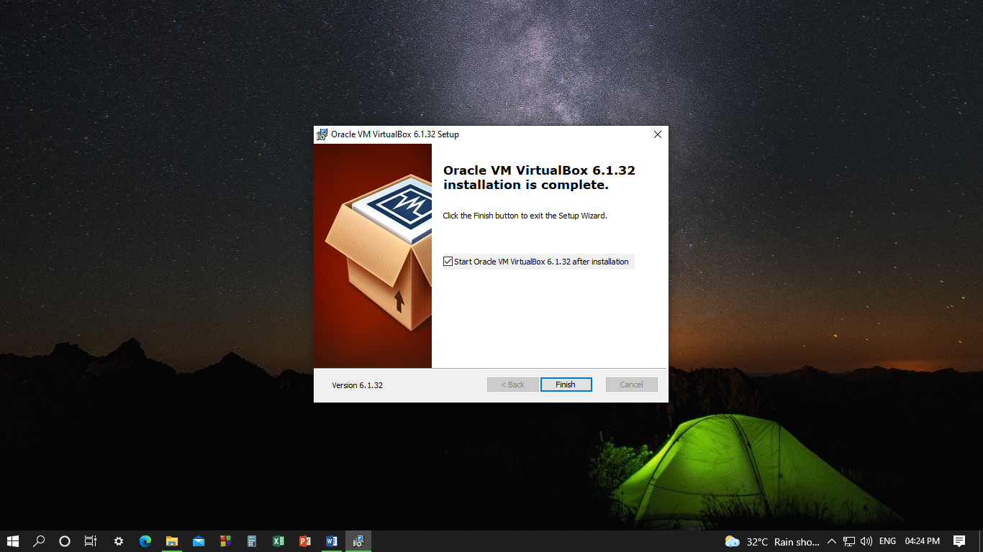

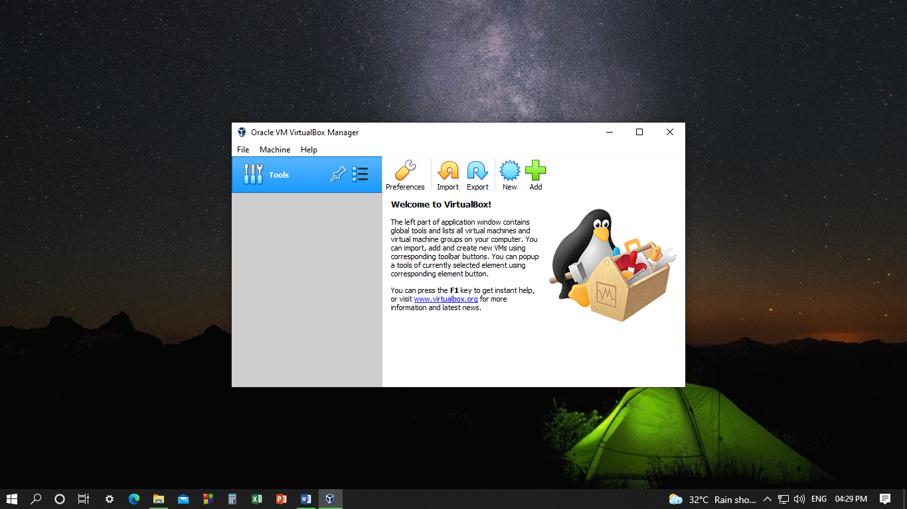

Step 5: Choose a descriptive name and destination folder for the new virtual machine and select the type of operating system you want to install on it.

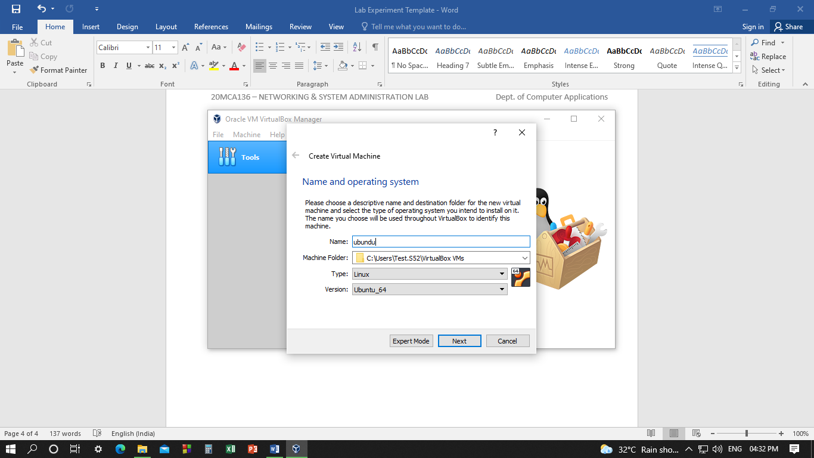

Step 6: Select the amount of memory allocate to virtual machine.

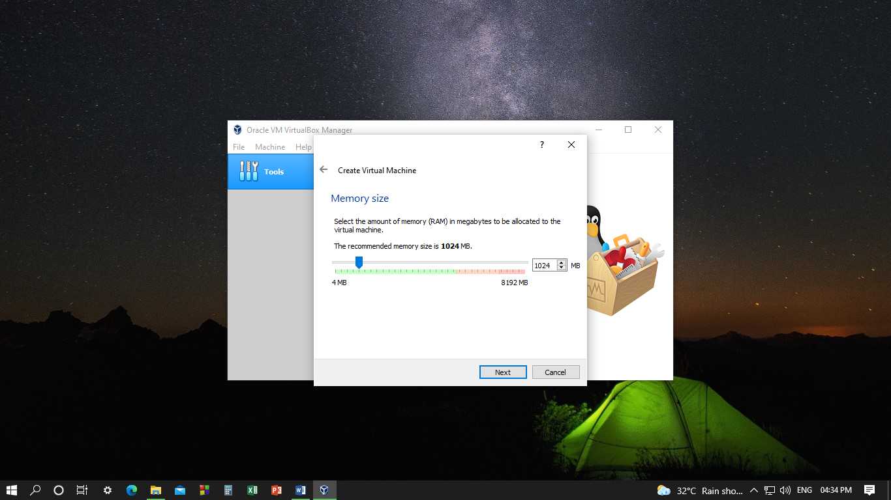

Step 7: Add a virtual hard disk for the new machine.

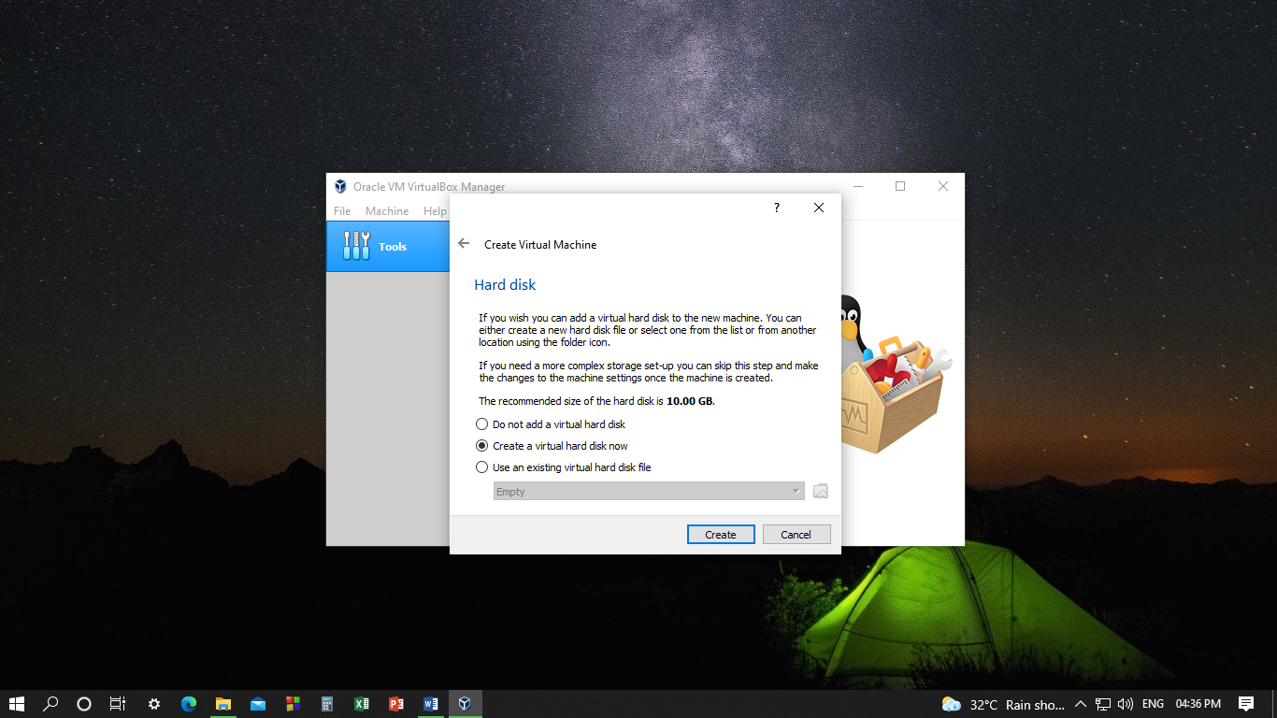

Step 8: Choose the type of file you want to use for the virtual hard disk.

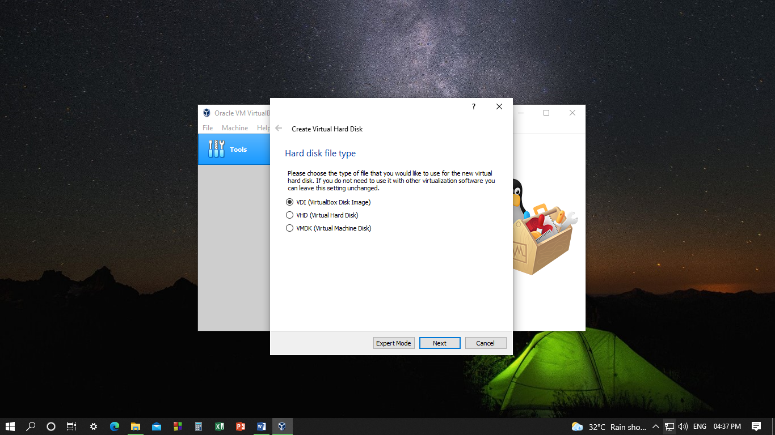

Step 9: Choose the storage on physical hard disk.

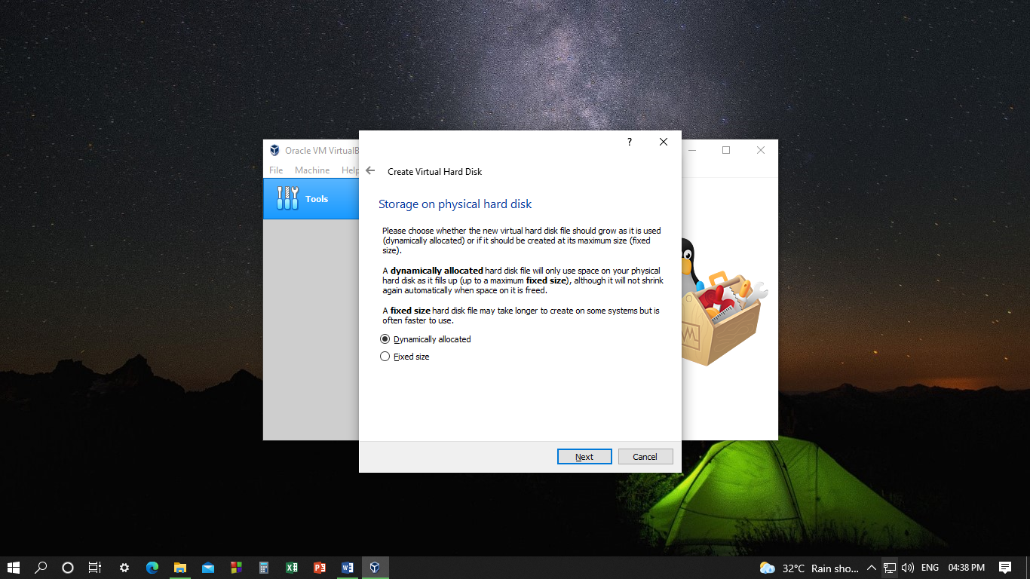

Step 10: Type the name of new virtual hard disk.

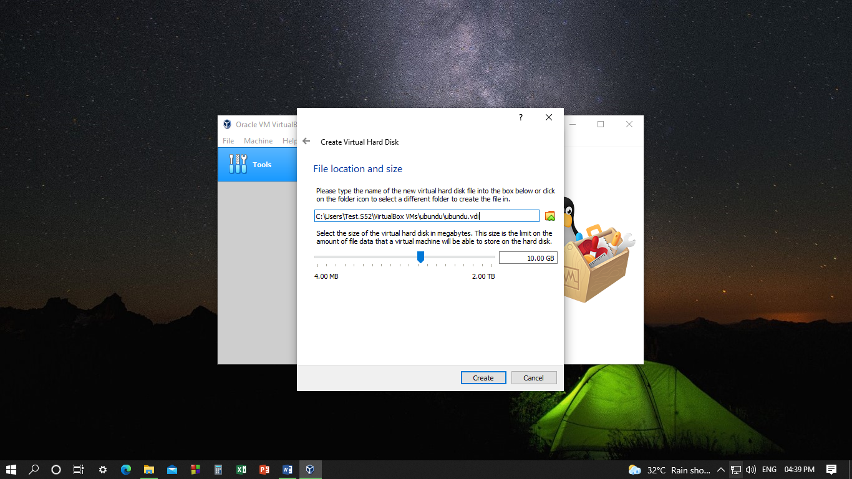

Step 11: Click on storage.

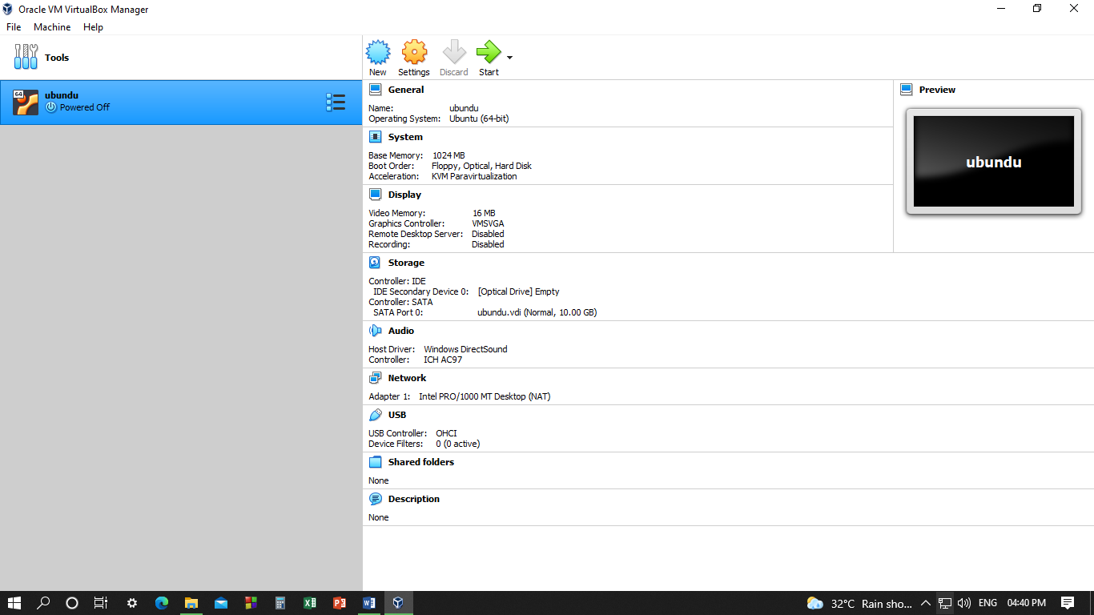

Step 11 : Click on Empty disk under Controller:IDE – choose iso image file of Ubuntu then Disk image on right side

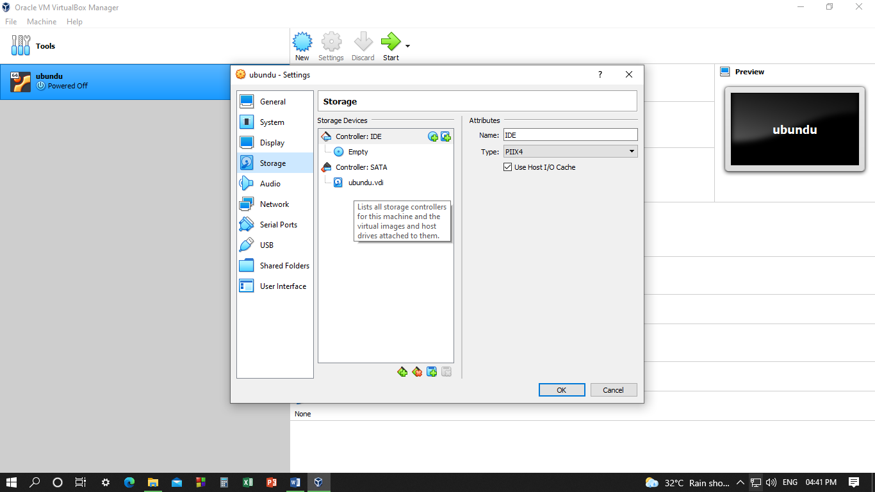

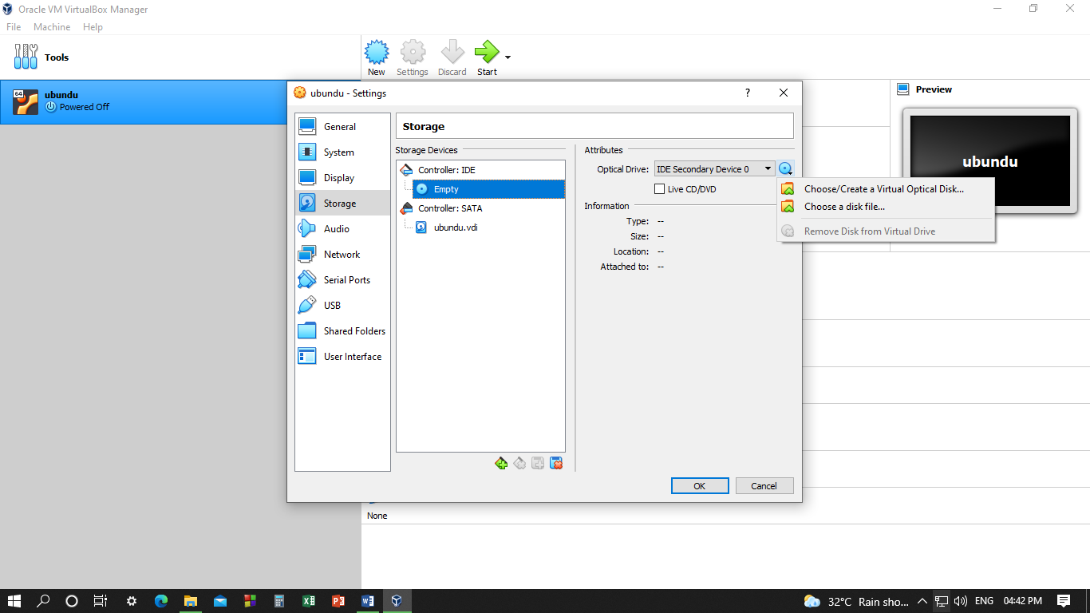

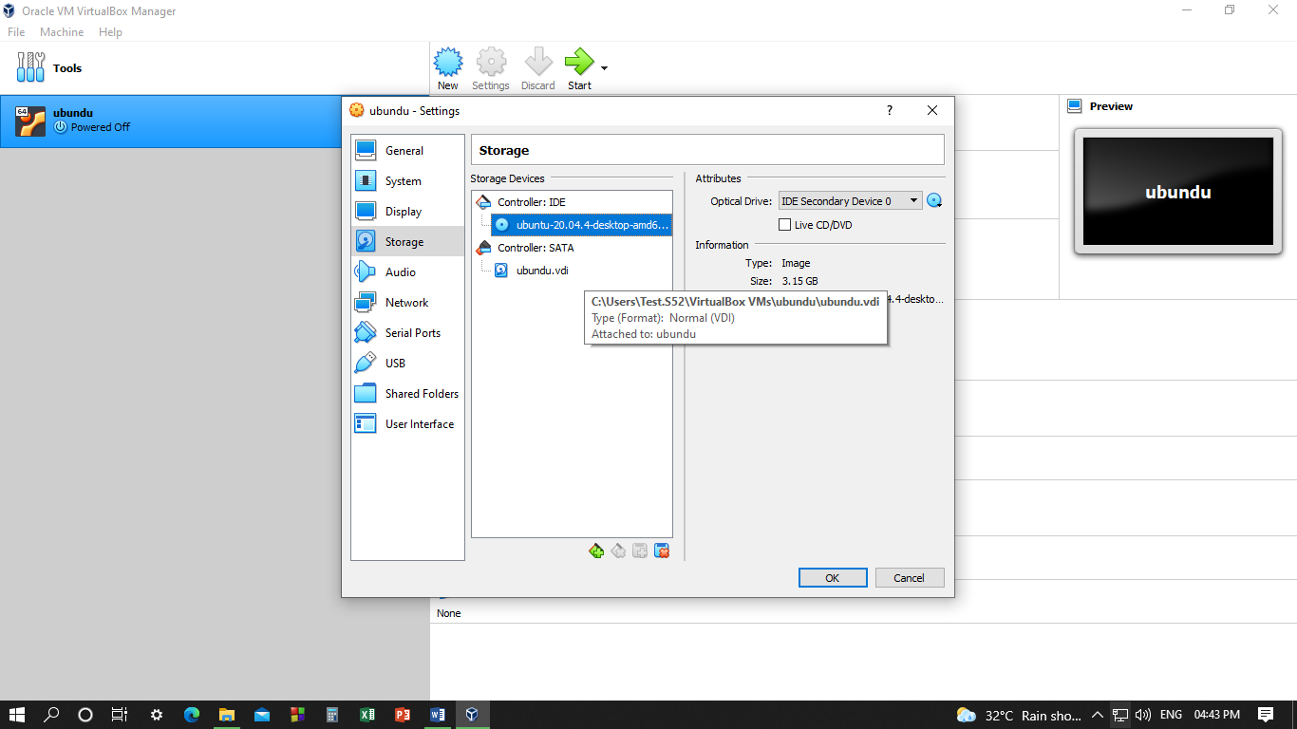

Step 12: Setup is complete click on Start

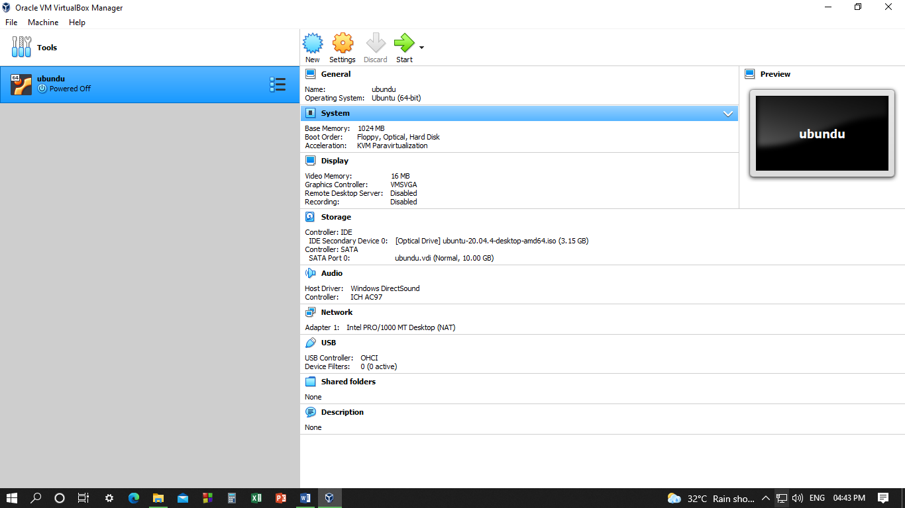

Step 13: Click on Install Ubuntu

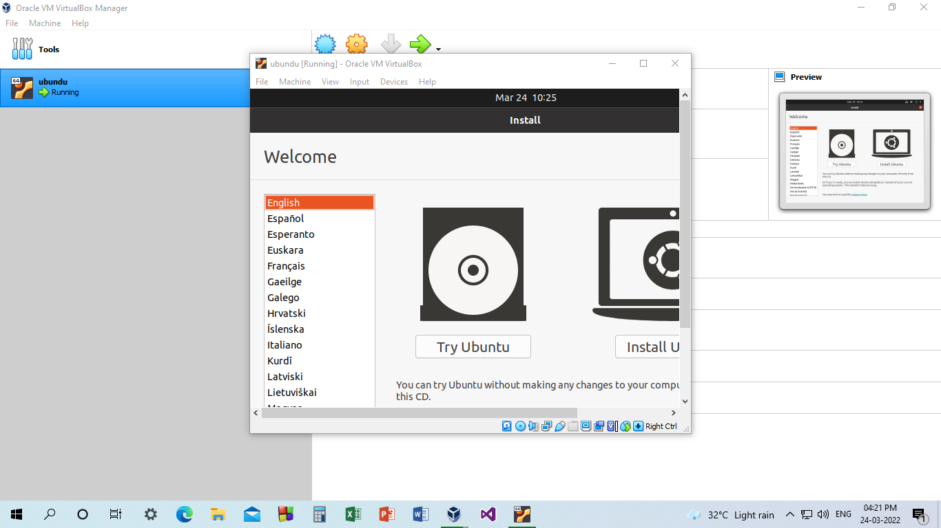

Step 14: Select the language for install ubuntu operating system

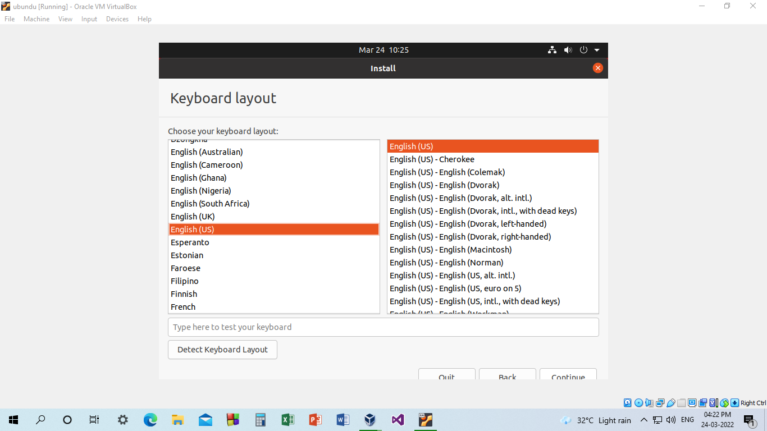

Step15: Selection of other installation within the installation of ubuntu

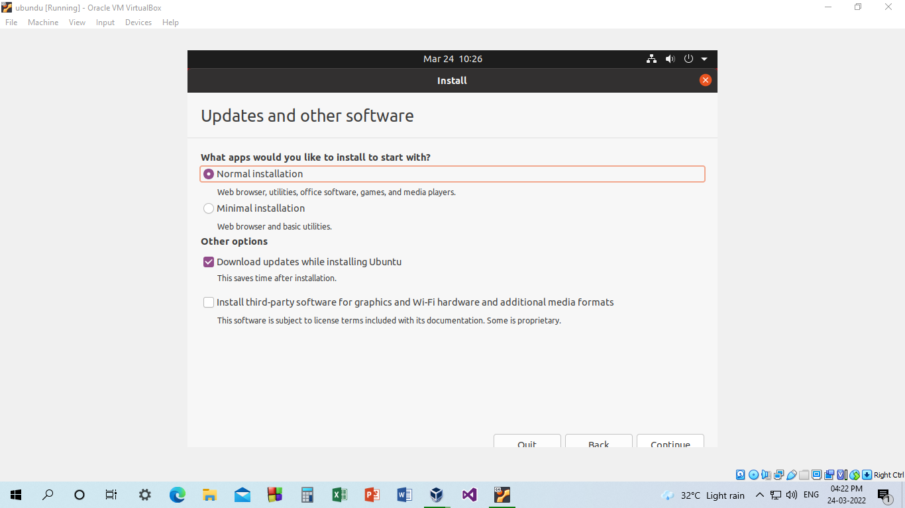

Step 16: Selecting the disk and create or resize partitions ourself,warning box is about formatting and partitioning of the allotted hard disk.

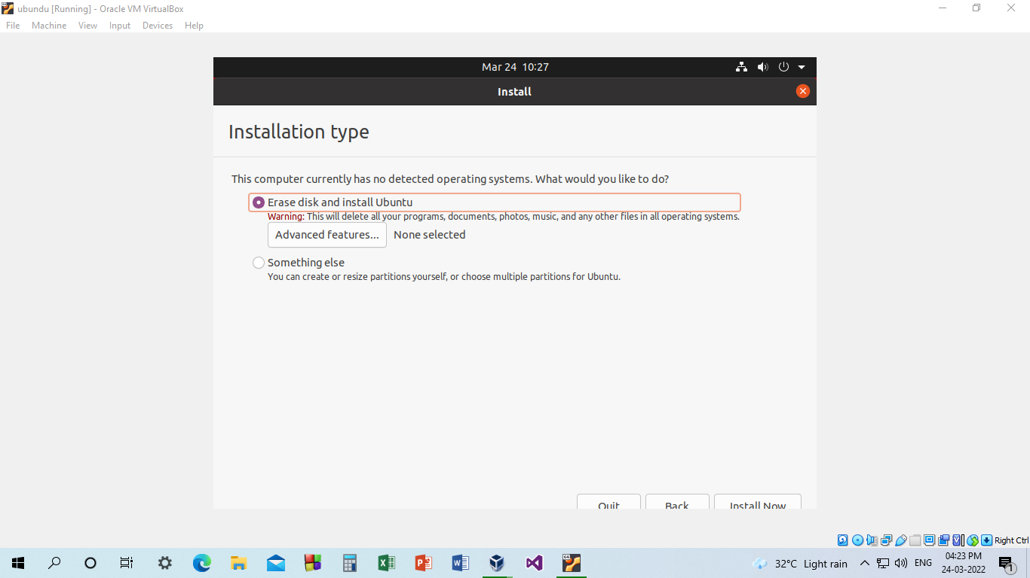

Step 17: To continue the changes listed will be written to the disk

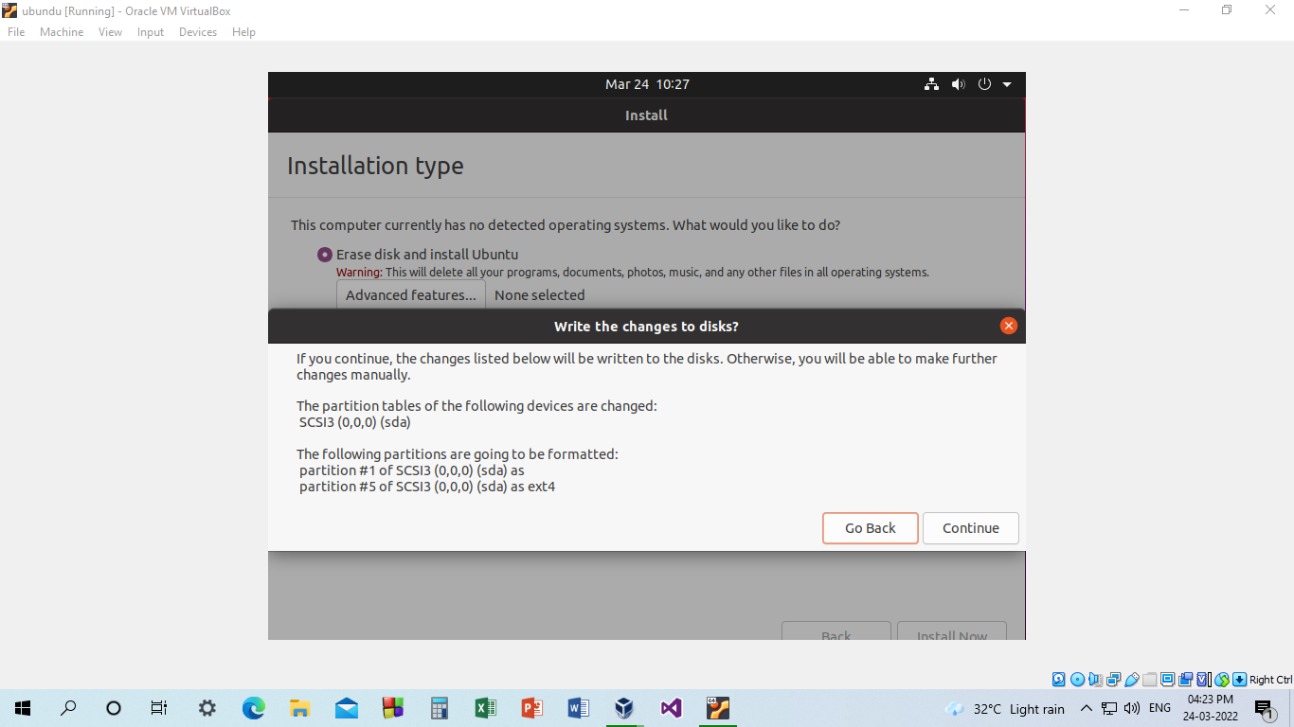

Step 18**:** Select the geographical location

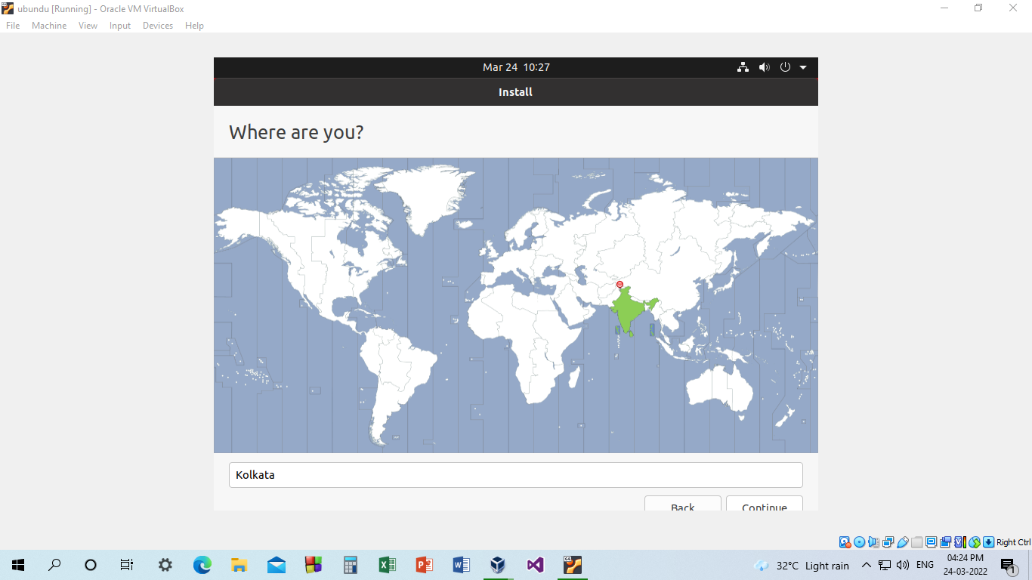

Step 19: Enter the name, username and password for the account to sign in to the

ubuntu OS after installation.

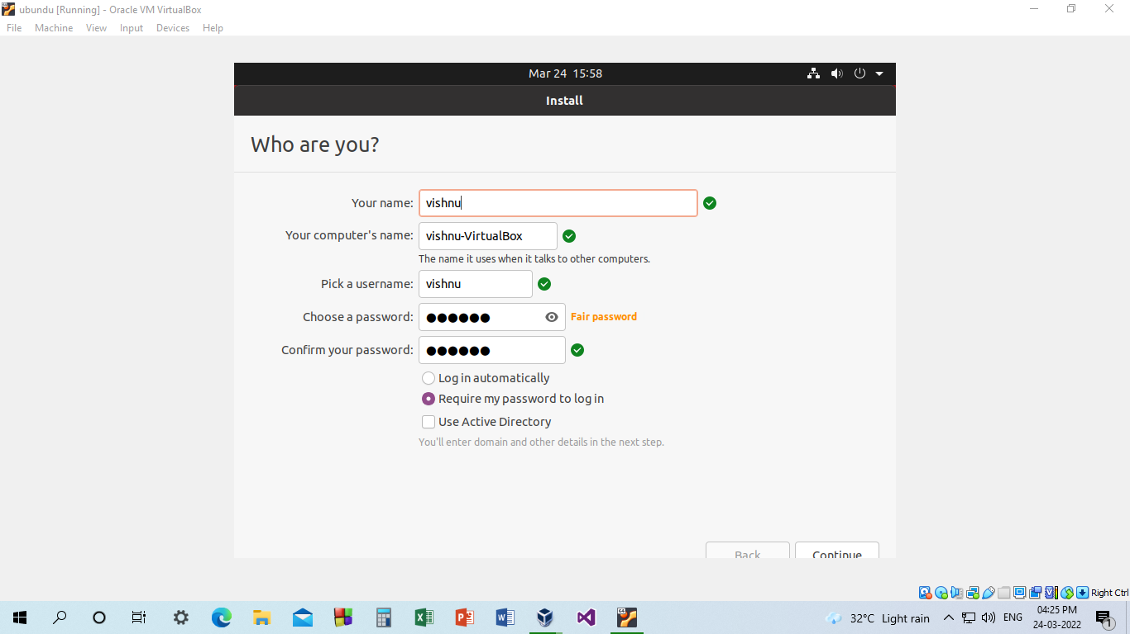

Step 20: Installing the ubuntu OS

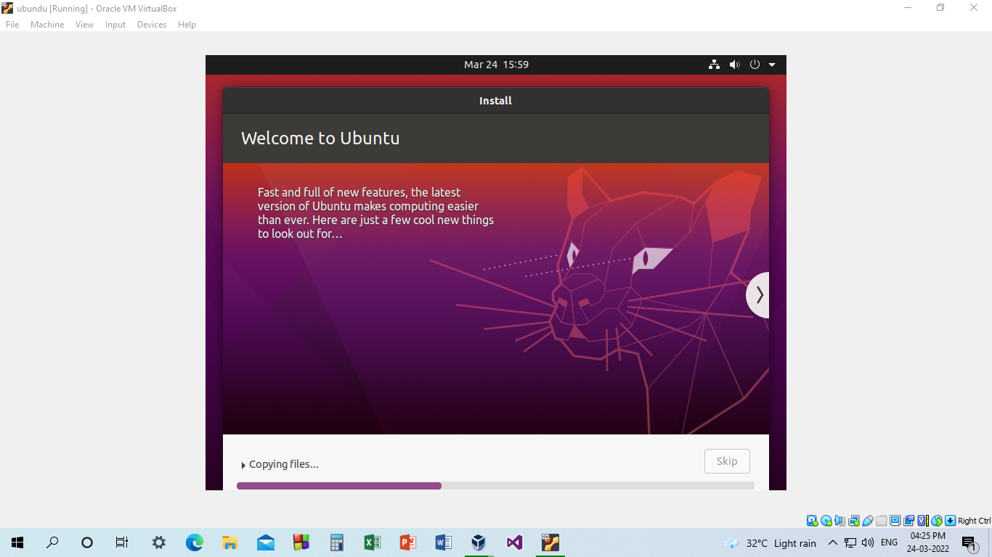

Step 21: Restart the OS to finalize the installation

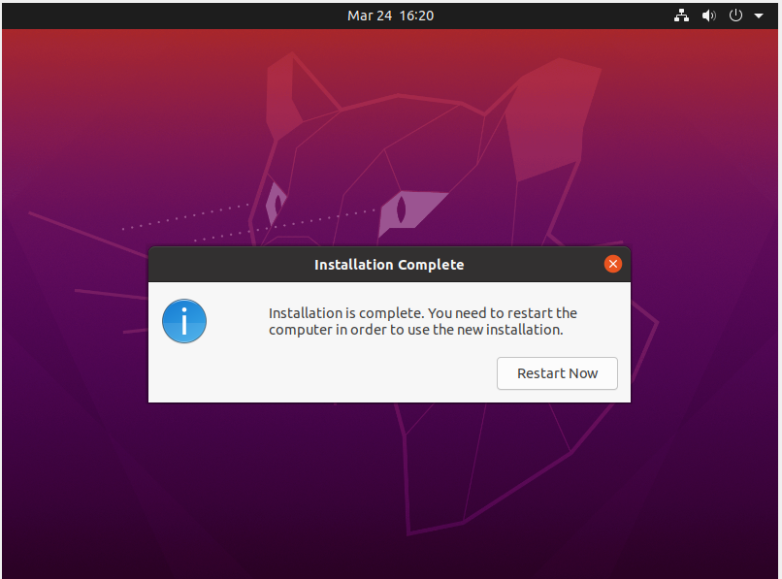

Step 22:Sign in and visit the home screen of ubuntu operating system using the registered username and password.

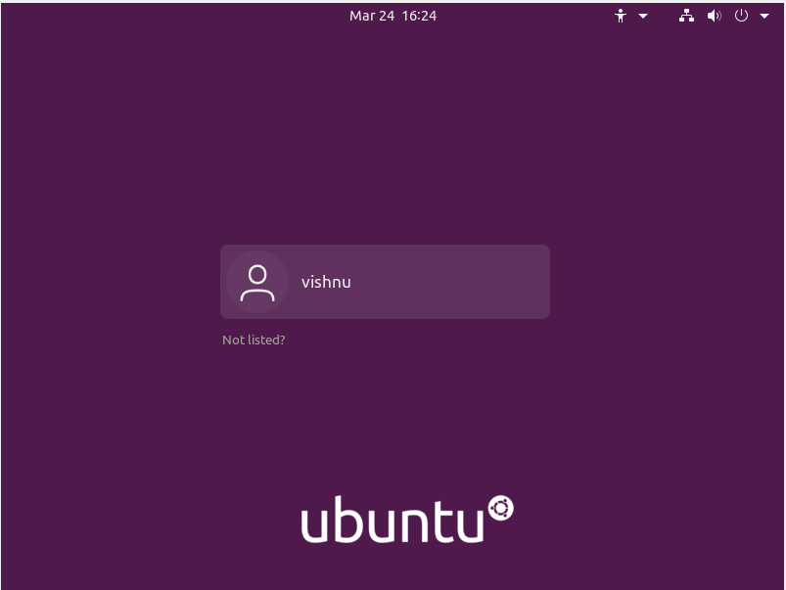

**Output Screenshot:**

